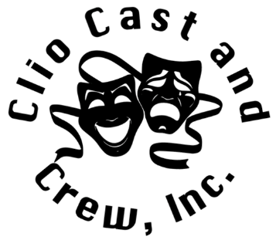
Krause and Kolkman
Memorial Scholarship Application

This scholarship is available to any person accepted into an artistic program at a post-secondary school. The award is $500 a year for two consecutive years of study, beginning with the 2026 academic year to be used for tuition or expenses related to continuing your education.
Requirements:
[ ] Completed and signed scholarship application.
[ ] A copy of current transcripts from your current high school or university (If currently enrolled)
[ ] Resume of past experiences
[ ] Letter to the scholarship board that is two pages long (10 pt., Times New Roman, double spaced). This should detail your career/credits as a performance artist or technician. Relate how your experiences have affected your life and how they incorporate into your long-range goals.
[ ] Two letters of recommendation from somebody involved in your
education or extracurricular activity that directly relates to your course of
study.

Completed application packets are to be postmarked no later than April 15, 2026, and mailed to:
Clio Cast and Crew, Inc.
Attn: Scholarship
PO Box 184
Clio, MI 48420

All applicants will receive a written response no later than June 30th.
Personal Information:
Full Name:
Address:
City, State, Zip:
Phone: |  | Birth date:

Education Information:
(If you are not currently enrolled, please list most recent school)

Current School:
City: |  |  | Graduation Date:
Special Certifications:
Where Certification was received:

College Information:
School Attending:
Location:
Course of Study:
[ ] Theatre | [ ] Music |  | [ ] Visual Arts | [ ] Photography
[ ] Film | [ ] Graphic Design |  | [ ] Art Education | [ ] Dance
[ ] Other:
How long is this course of study?
Have you been accepted into this program? [ ] Yes [ ] No
If no, please explain:

Parental Information:
Name:
Address:
City, State, Zip:
Contact Phone:
Extracurricular information:
Please list any extracurricular activities that you have been involved in that pertain to your course of study and explain your involvement:
Please list any additional experience you have received that will help prepare you for your education:

I certify the above information is true and accurate. If any of the information is proven to be false, I will no longer be considered for this scholarship. I understand that my age, ethnicity or gender play no role in determining this scholarship. It is based solely on merit.

Applicant Signature: __________________________________ Date: _____________

Parent/Guardian Signature: ____________________________ Date: ____________
(If the applicant is under the age of 18)

